==================================================

Running Genetic Algorithm...

==================================================

==================================================

=== GENETIC ALGORITHM OPTIMIZATION ===

==================================================

[Initialization]

- Population size: 30

- Generations: 20

- Crossover rate: 80%

- Mutation rate: 20%

- Search space: 14 features

- Target: Minimize MSE using XGBoost

==================================================

=== OPTIMIZATION RESULTS ===

==================================================

▶ Best MSE achieved: 0.494339

▶ Time elapsed: 255.03 seconds

▶ Features selected: 14/14 (0.0% reduction)

▶ Selected features:

1. 0

2. 1

3. 2

4. 3

5. 4

6. 5

7. 6

8. 7

9. 8

10. 9

11. 10

12. 11

13. 12

14. 13

▶ Convergence progress:

- Initial MSE: 0.4986

- Final MSE: 0.4943

- Improvement: 0.9%

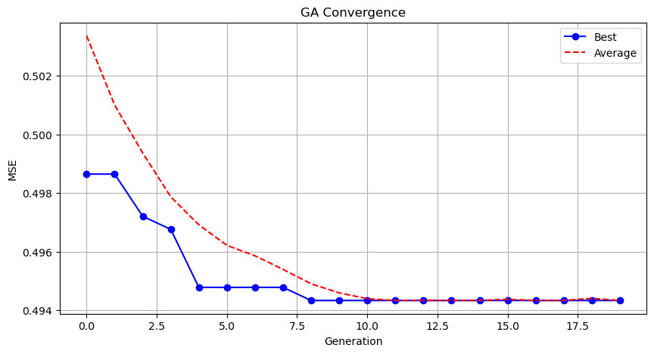

Genetic Algorithm completed successfully with MSE: 0.4943

==================================================

Running Particle Swarm Optimization...

==================================================

==================================================

=== PARTICLE SWARM OPTIMIZATION ===

==================================================

[Initialization]

- Swarm size: 30 particles

- Iterations: 20

- Cognitive weight: 0.5

- Social weight: 0.5

- Inertia weight: 0.5

- Search space: 14 features

- Target: Minimize MSE using XGBoost

[Optimization Progress]

No constraints given.

==================================================

=== OPTIMIZATION RESULTS ===

==================================================

▶ Best MSE achieved: 0.494339

▶ Time elapsed: 274.46 seconds

▶ Features selected: 14/14 (0.0% reduction)

▶ Selected features (with weights):

1. 0 (weight: 0.629)

2. 1 (weight: 0.879)

3. 2 (weight: 0.943)

4. 3 (weight: 0.612)

5. 4 (weight: 0.939)

6. 5 (weight: 0.772)

7. 6 (weight: 0.918)

8. 7 (weight: 0.511)

9. 8 (weight: 0.569)

10. 9 (weight: 0.765)

11. 10 (weight: 0.533)

12. 11 (weight: 0.572)

13. 12 (weight: 0.855)

14. 13 (weight: 1.000)

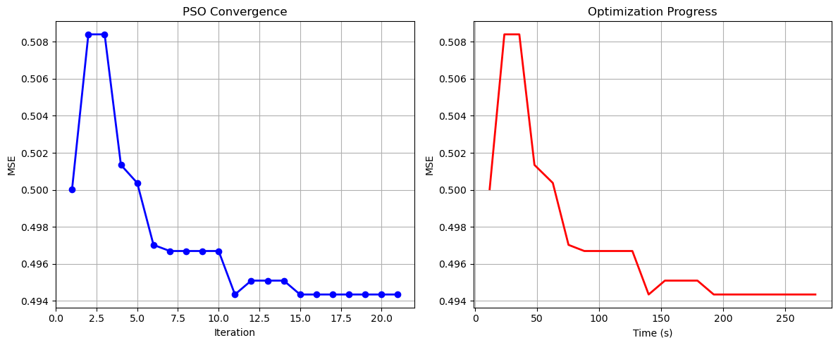

Particle Swarm Optimization completed successfully with MSE: 0.4943

==================================================

Running Whale Optimization...

==================================================

==================================================

=== WHALE OPTIMIZATION ALGORITHM ===

==================================================

[Initialization]

- Population: 30 whales

- Max iterations: 20

- Spiral coefficient (b): 1.0

- Search space: 14 features

- Target: Minimize MSE using XGBoost

[Optimization Progress]

Iter 20/20 | Best MSE: 0.494339

==================================================

=== OPTIMIZATION RESULTS ===

==================================================

▶ Best MSE achieved: 0.494339

▶ Time elapsed: 267.83 seconds

▶ Features selected: 14/14 (0.0% reduction)

▶ Selected features:

1. 0

2. 1

3. 2

4. 3

5. 4

6. 5

7. 6

8. 7

9. 8

10. 9

11. 10

12. 11

13. 12

14. 13

▶ Convergence progress:

- Initial MSE: 0.5103

- Final MSE: 0.4943

- Improvement: 3.1%

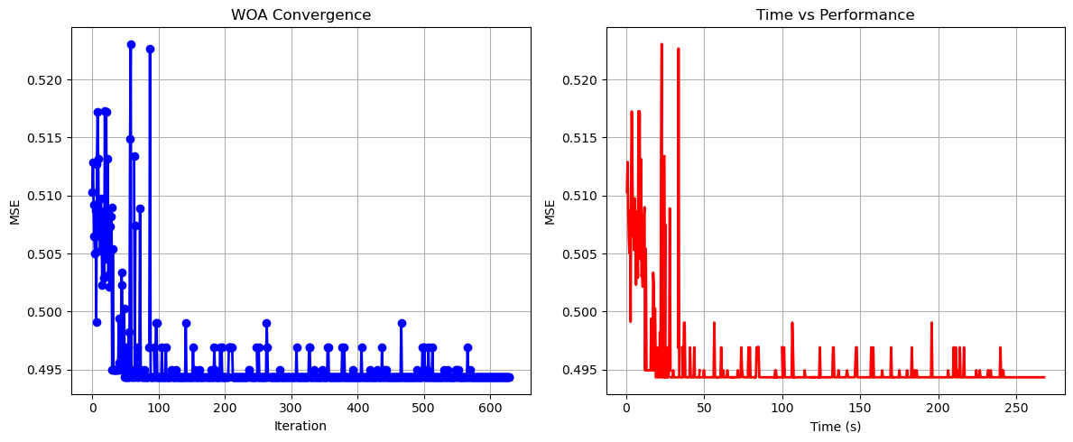

Whale Optimization completed successfully with MSE: 0.4943

==================================================

Running Squid Game Optimizer...

==================================================

==================================================

=== SQUID GAME OPTIMIZER (SGO) ===

==================================================

[Initialization]

- Players: 30 (15 offensive, 15 defensive)

- Max games: 20

- Search space: 14 features

- Target: Minimize MSE using XGBoost

==================================================

=== OPTIMIZATION RESULTS ===

==================================================

▶ Best MSE achieved: 0.496269

▶ Time elapsed: 256.92 seconds

▶ Features selected: 12/14 (14.3% reduction)

▶ Selected features:

1. 0

2. 1

3. 2

4. 3

5. 4

6. 5

7. 6

8. 8

9. 10

10. 11

11. 12

12. 13

▶ Convergence progress:

- Initial MSE: 0.4982

- Final MSE: 0.4963

- Improvement: 0.4%

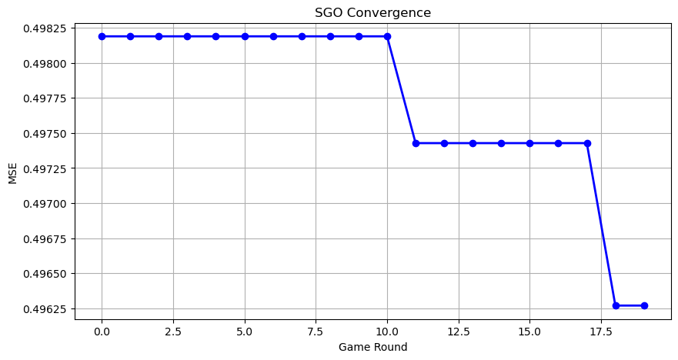

Squid Game Optimizer completed successfully with MSE: 0.4963

==================================================

Running PSH-Hyptrite...

==================================================

==================================================

=== PSH-HYPTRITE OPTIMIZATION ===

==================================================

[Initialization]

- Search points: 30

- Max iterations: 20

- Initial radius: 0.5 (adaptive)

- Hypersphere samples: 3 per point

- Search space: 14 features

- Target: Minimize MSE using XGBoost

[Optimization Progress]

Iter 20/20 | Best MSE: 0.494339 | Radius: 0.0250

==================================================

=== OPTIMIZATION RESULTS ===

==================================================

▶ Best MSE achieved: 0.494339

▶ Time elapsed: 791.13 seconds

▶ Features selected: 14/14 (0.0% reduction)

▶ Selected features (with weights):

1. 0 (weight: 1.000)

2. 1 (weight: 0.832)

3. 2 (weight: 0.663)

4. 3 (weight: 0.786)

5. 4 (weight: 0.651)

6. 5 (weight: 0.951)

7. 6 (weight: 0.885)

8. 7 (weight: 0.603)

9. 8 (weight: 0.870)

10. 9 (weight: 0.767)

11. 10 (weight: 0.519)

12. 11 (weight: 1.000)

13. 12 (weight: 0.970)

14. 13 (weight: 0.863)

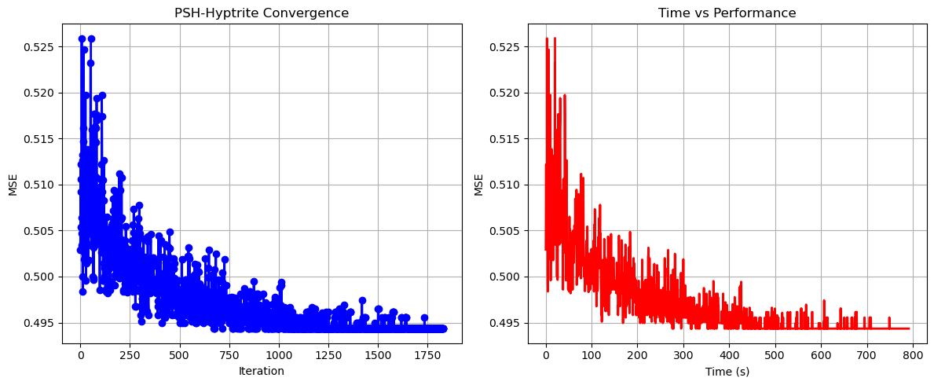

PSH-Hyptrite completed successfully with MSE: 0.4943

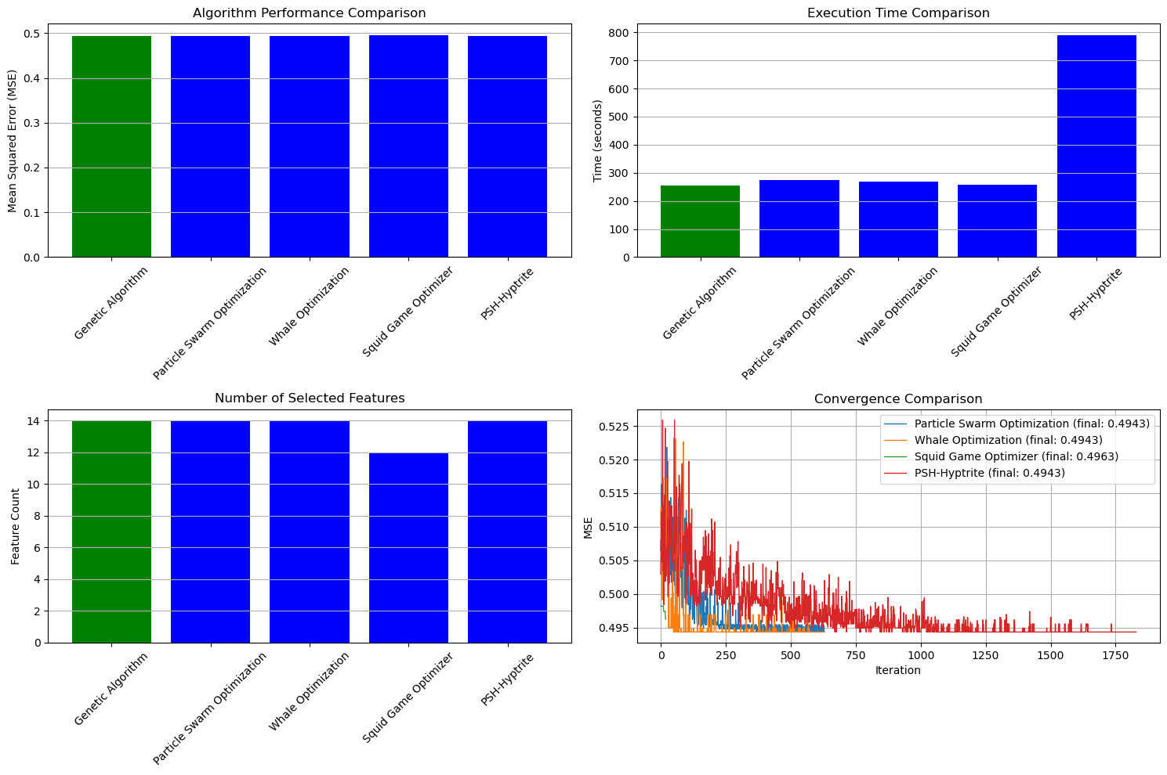

==================================================

FINAL RESULTS SUMMARY

==================================================

🏆 Best Algorithm: Genetic Algorithm

📉 Best MSE Achieved: 0.494339

⏱️ Execution Time: 255.03 seconds

🔢 Features Selected: 14

Selected Features:

1. 0

2. 1

3. 2

4. 3

5. 4

6. 5

7. 6

8. 7

9. 8

10. 9

11. 10

12. 11

13. 12

14. 13